Lab 3

Exercise#1: Design an 8:1 multiplexer (without in-built blocks) using two 4:1 multiplexers and one 2:1multiplexer (shown in Fig.1) Use both types of multiplexers as sub circuits in the design.

Boolean Expressions | Logic Diagram
output = i7 s0 s1 s2 + i6 ~s0 s1 s2 + i5 s0 ~s1 s2 + i4 ~s0 ~s1 s2 + i3 s0 s1 ~s2 + i2 ~s0 s1 ~s2 + i1 s0 ~s1 ~s2 + i0 ~s0 ~s1 ~s2 | 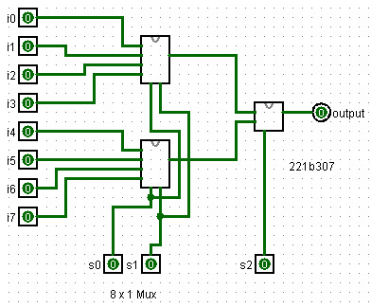
Truth Table or Karnaugh (K) Map

Exercise#2: Design a 1:8 de-multiplexer (without in-built blocks) using three 1:4 de-multiplexers. Use 1:4 de-multiplexers as sub circuits in the design

Boolean Expressions | Logic Diagram
Demux 1 x 8 | 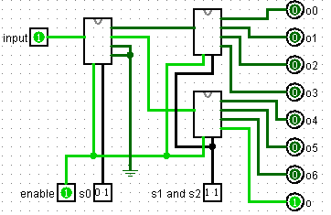
Truth Table or Karnaugh (K) Map

Exercise#3: Design quad to binary (4-to-2) encoder (without in-built blocks) using logic gates. Display all four input digits using seven segment displays and two output binary bits using hex displays available in logisim simulator.

Boolean Expressions | Logic Diagram
o0=i1 + i3  01=i2 + i3 | 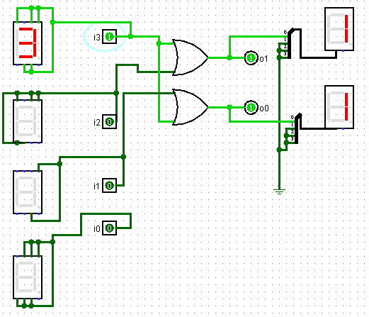
Truth Table or Karnaugh (K) Map
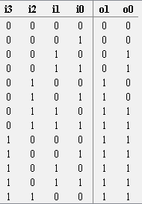

Exercise#4: Design 3-to-8 decoder (without in-built blocks) using two 2-to-4 decoders with enable (E) line
shown in Fig. 2. Use 2:4 decoder as sub circuits in the design.
Boolean Expressions | Logic Diagram
3 to 8 decoder | 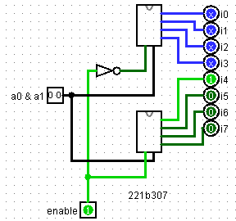
Truth Table or Karnaugh (K) Map

